Title of your extended abstract (DM Sans font, 14 pt, left justified)
(The publication of this extended abstract will undergo a double-blind review process. Therefore, please do not include any author names, affiliations, or data that could be related to authorship in this document. Please remove this text before submission.)

SUMMARY (DM Sans font Bold, 12 pt, UPPERCASE, style: Heading 1)
Prepare an informative summary of fewer than 150 words. Like an abstract, the summary should include information on the study's purpose, methods or procedures, results, and discussion or interpretation of the results. If feasible, it should also indicate the meaning or importance of the work. The summary should be self-contained, giving the reader a clear indication of the paper's purpose and content. Use DM Sans font, 11 pt (style: Normal) for the summary.

KEYWORDS
Select up to five terms or brief phrases that best describe your paper's content. Separate each term or phrase with a semi-colon (e.g., Keyword 1; Keyword 2; Keyword 3; Keyword 4; Keyword 5). Phrases should contain no more than three words. Do not use words that are identical to those in the title of the paper.

INTRODUCTION
The introduction should provide a practical and scientific background of the research topic and any tested hypotheses, as well as a clear statement of the work's objective(s).
The extended abstract should be between 1,200 and 1,500 words, excluding references, and must not exceed three pages. Please use the format in these pages, ISO A4 paper size (210 × 297 mm), with margins of 25 mm on all sides. Do not include page numbers. The main text should use DM Sans, 12 pt, and the Normal style. Paragraphs should be justified on both sides.
Main headings should use DM Sans, 12 pt, bold and uppercase, using the Heading 1 style. Second-level headings should use DM Sans, 12 pt, bold and sentence case, using the Heading 2 style. Accepted file formats are .docx or .doc, and the submitted file must not exceed 5 MB.
In-text citations should include the author’s surname and year of publication, separated by a comma. For works with two authors, include both surnames. For works with three or more authors, use the first author’s surname followed by et al. When the author’s name is included in the sentence, only the year should appear in parentheses. For organisational authors, use the organisation’s initials or acronym where appropriate. For example: “ASHRAE (1992) relied on previous research (Fanger, 1970; Hanzawa et al., 1982) in developing its standard.”
Authors should use spelling and grammar checking tools before submission. The organising committee may make minor editorial changes to improve clarity and correct English usage. Authors will be consulted if substantial changes are required.
Further information about the submission and review process, including relevant deadlines, is available on the conference website.

METHODS
The Methods section should describe the study's design, materials, measurement methods, procedures, and statistical methods. Both measurement and statistical methods should be mentioned and described. References should be included for case studies and practical applications of routine methods.
Contributions must present new information on scientific validation, comparative testing, research, development, or policy. Please note that commercialism is absolutely prohibited. Presentations must objectively summarize a topic and may not promote any product, service, company, or organization. Mentioning specific products, services, companies, or organizations is permitted only if they serve as examples of the topic being addressed (e.g., case study).

RESULTS
The Results section should describe the outcomes of the study. For a synergistic Results and Discussion section, the two sections may be combined if desired.

Tables and figures (DM Sans font Bold, 11 pt, lowercase, style: Heading 2)
In general, use tables and figures when they are shorter and clearer than textual explanations. If you use shading or color, check the black-and-white reproduction by making a photocopy or printing in grayscale. Avoid tables and figures that duplicate each other or present superfluous data. If you use a figure, do not also include a table with the same information. When practical, substitute a few typical results for lengthy tables. All tables must have captions above them. Use the single-line border style for tables, as shown in Table 1. Insert tables and figures in the text after and close to where they are first mentioned. Do not extend tables or figures beyond the margins. You may use a 11 pt font size for tables and captions.

Table 1: Tables are numbered. The table caption is above the table.
Column Title | Column Title | Column Title | Column Title | Column Title
Table content
Insert figures as ‘picture’ (e.g. wmf, jpg, or pdf), not as ‘objects’ or spreadsheets. Reduce the resolution of photos to 72 pixels/inch.

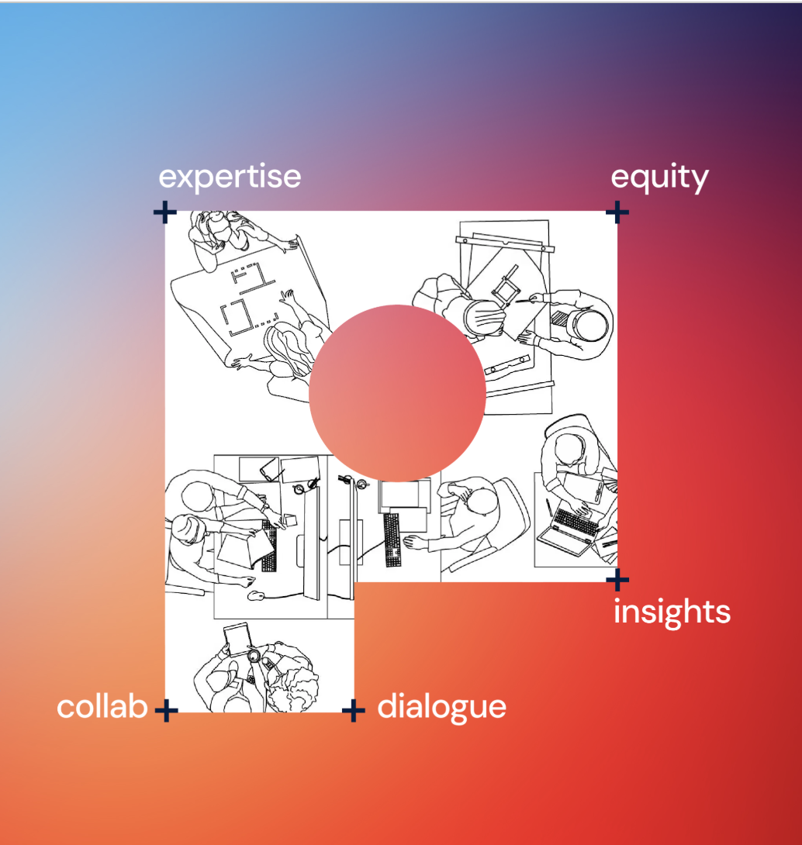

Figure 1: An example of a figure. All figures are numbered and must have suitable captions below the figure.

Equations
Equations should be formatted using an equation editor and numbered in the right margin. Symbols and their units should be introduced immediately after the equation appears for the first time in the text, as in this example.

$Q = U * A * ΔT$ (1)

where Q (W) is the heat flow; U (W/m²·K) is the overall heat transfer coefficient; A (m²) is the area of the surface; and ΔT (K) is the temperature difference between the inside and outside. Use italic symbols for quantities and variables. Punctuate equations with commas or periods when they are part of a sentence.

Names and units
The metric system (with SI units) should be used. Frequently used technical terms may be abbreviated after the first time they are mentioned (e.g., “indoor air quality (IAQ)).

DISCUSSION
In this section, the most important findings of the paper should be discussed in the context of existing literature and knowledge. Any possible sources of error that could affect the interpretation of the results should also be discussed here. The discussion section should present the authors' interpretation of the results. The Discussion section may be combined with the Results section to create a Results and Discussion section, if desired.

CONCLUSIONS
Instead of simply repeating your results or discussion in this section, provide some overall observations regarding the findings. For example, discuss their applicability in other settings or applications. This section should explain the importance of your work to others, including researchers, building designers, owners and operators, and occupants.

ACKNOWLEDGEMENTS
Please list the individuals that provided help to this work. Sources of financial aid should always be noted.

REFERENCES
Include references to cited works in the Reference list. Do not use any blank lines between references. Instead, use a hanging indent of 0.5 cm, as in the examples below. The references should be in alphabetical order and follow the abridged format (omit titles).
ASHRAE. 1992. ANSI/ASHRAE Standard 55-1992. Atlanta: ASHRAE, Inc.
Chen Q. 1988. Ph.D. Thesis, Delft University of Technology, The Netherlands.
Fanger PO. 1970. Thermal Comfort. Copenhagen: Danish Technical Press.
Hanzawa H, Melikov AK, Fanger PO. 1987. ASHRAE Transactions. 93(1):10-20.
Kimura K, Tanabe S. 1993. In: Proceedings of the 6th International Conference on Indoor Air Quality and Climate – Indoor Air ’93, Helsinki, Vol. 6:61-66.
Olesen BW. 2004. Indoor Air. 14(Suppl 7):18-26.

